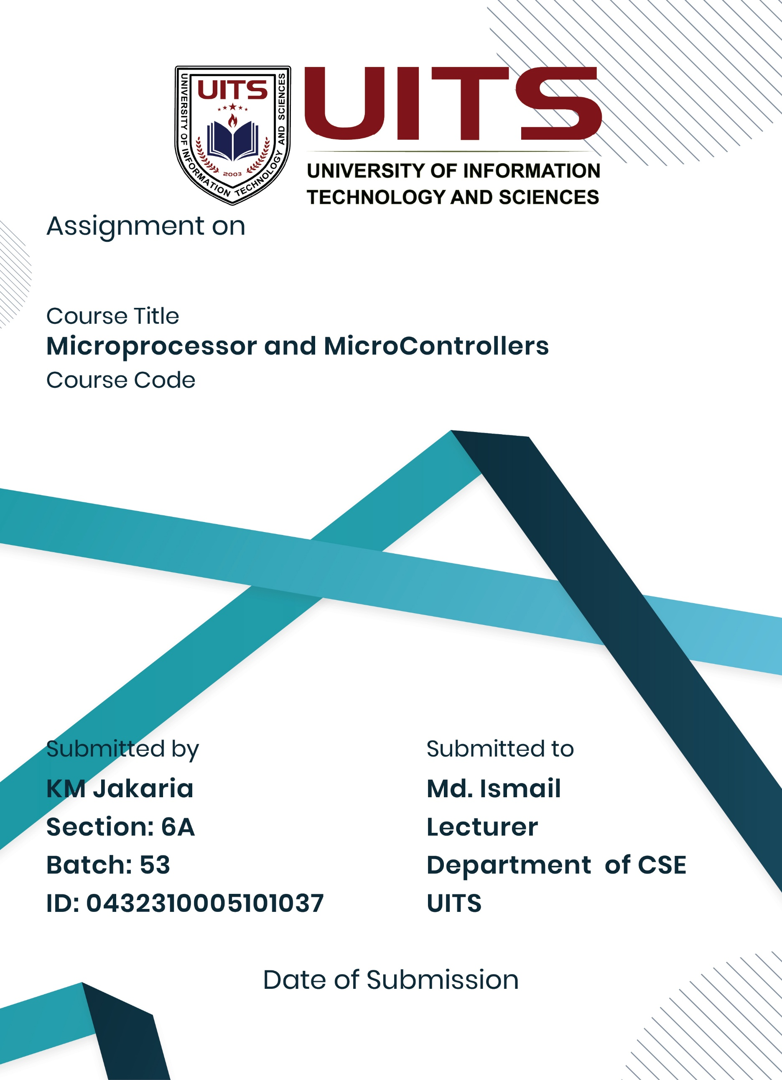
03 Sept, 2025
Lab Report- 05
CSE 360
Problem No: 01
Experiment No: 01
Experiment Name: Write an assembly language program to print an array of
characters and an array of strings
Process:
Set registers to point to the array's beginning. To access each character in the character array and load it into the corresponding register, utilize a loop or direct offset. The address of each string in the string array should be loaded into the register using a loop or direct offsets. To display every character or string on the screen, use the int 21h function 09h.
For the string array, print a new line after every string. Continue doing this until every character or string in the array has been shown.
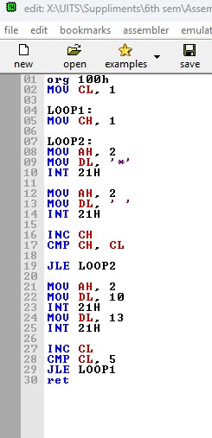
Implementation:

Result:
The application displays every character array element on the screen. Every string in the string array is printed on a separate line by the application.
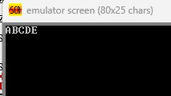

Conclusion:
Both a string array and a character array are successfully printed on the screen by the applications. They explain how to read and display individual characters and strings in a sequential manner using registers, memory addressing, and the int 21h output function in 8086 assembly language.

Problem No: 02
Experiment No: 02
Experiment Name: Write an assembly language program to print an array of
characters and an array of strings
Process:
Set up registers to point to the array's beginning. To access each character in the character array and load it into the corresponding register, utilize a loop or direct offset. The address of each string in the string array should be loaded into the register using a loop or direct offsets. To show each character or string on the screen, use the int 21h function 09h. For the string array, print a new line after every string. Continue doing this until every character or string in the array has been shown.

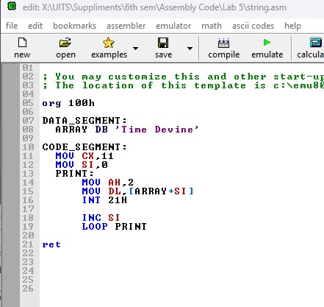
Implementation:

Result:
Every character array element is printed on the screen by the application. Every string in the string array is printed on a separate line by the application.
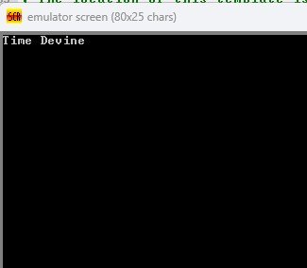

Conclusion:
Both a string array and a character array are successfully printed on the screen by the applications. They explain how to read and display individual characters and strings in a sequential manner using registers, memory addressing, and the int 21h output function in 8086 assembly language.

